Project 5-1: Downloading and Running the Microsoft Safety Scanner
Estimated Time: 20 minutes
Objective: Scan a computer for malware.
Description: Microsoft offers a free tool that can scan a computer for malware and then remove it. In this project, you download and run the Microsoft Safety Scanner.
- Open your web browser and enter the URL docs.microsoft.com/en-us/microsoft-365/security/intelligence/safety-scanner-download. (If you are not able to access the site through the web address, use a search engine to search for “Microsoft Safety Scanner Download.”)
- Read the information on this webpage about the scanner.
- Click the link Download Microsoft Safety Scanner (64-bit).
- After the MSERT.exe file downloads, open the file by double-clicking it.

Caution: Note where you saved this download. The Microsoft Safety Scanner is a portable executable and will not appear in the Windows Start menu or as an icon on the desktop.

- Answer Yes if asked Do you want to allow this app to make changes to your device?
- When the End user license agreement appears, click in the box Accept all terms of the preceding license agreement and click Next.
- When the Welcome to the Microsoft Safety Scanner window appears, click Next.
- When the Scan type window appears, if necessary, click Quick scan. Click Nextto have the Microsoft Safety Scanner performs a limited scan of the computer. This scan may take up to five minutes to complete depending on the computer’s configuration.
- Review the Scan results window that appears when the scan is completed. If any suspicious files or malware are detected, you may be asked to conduct a full scan.
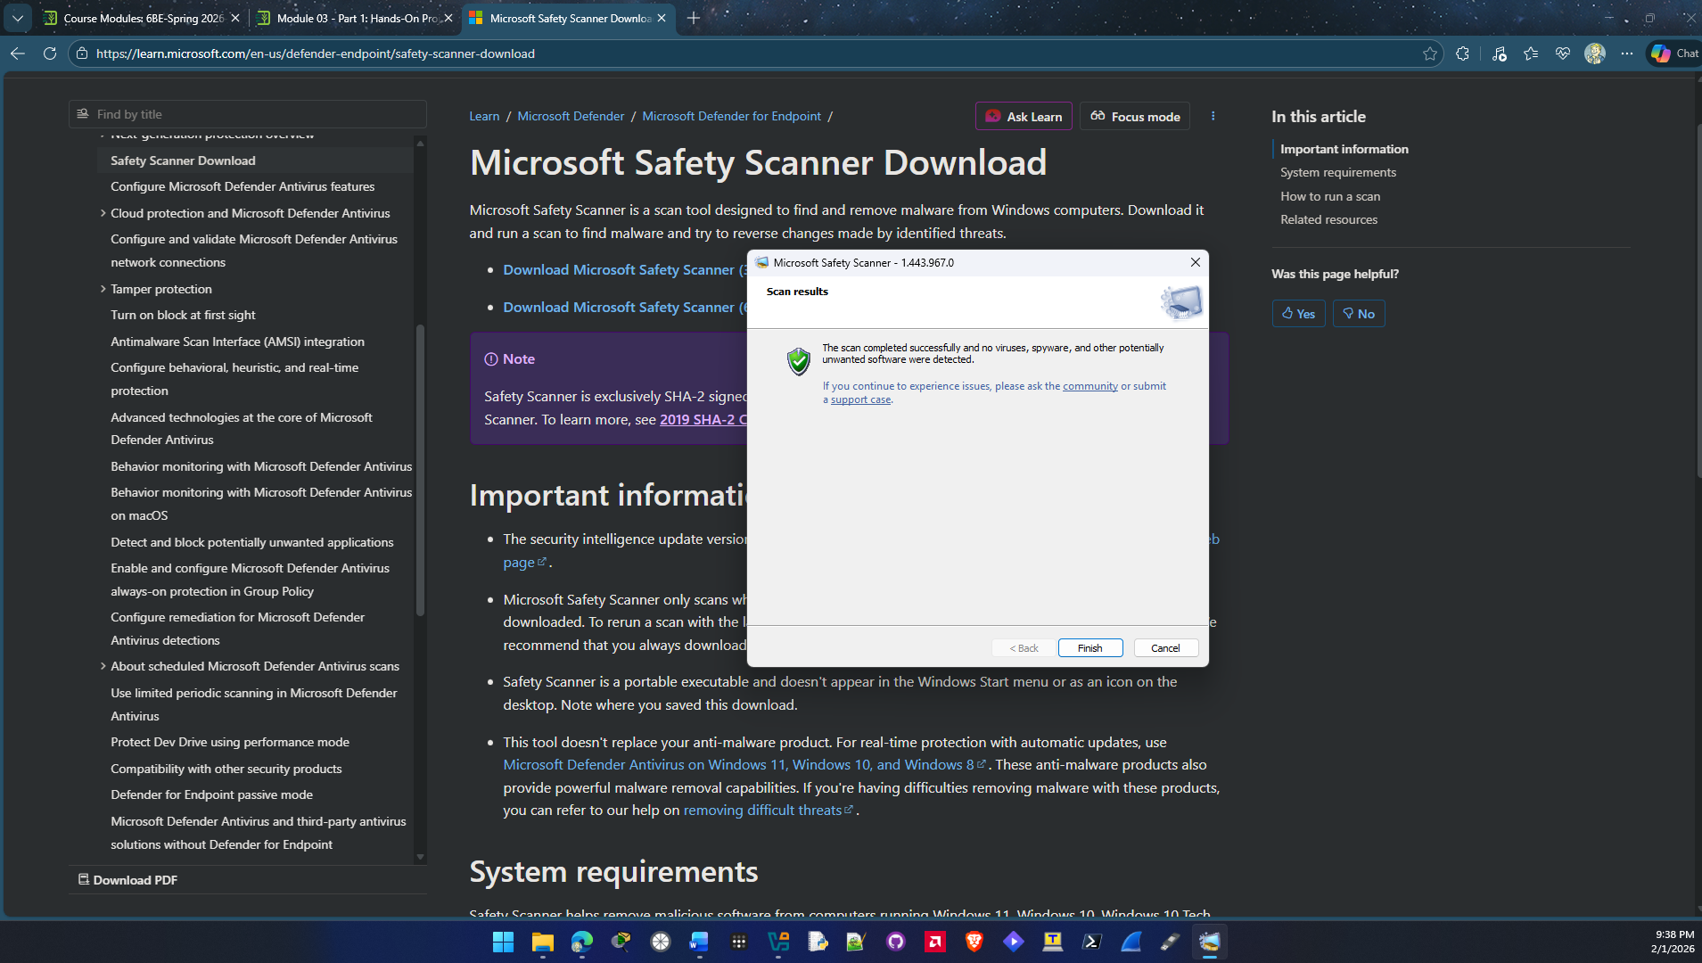
- How easy was this scanner to use? Is this something that you would recommend to a friend? Why or why not?

The scanner was very easy to use and since it was a portable application there was no need to install it making it easier. Yes I would recommend this application to a friend. It’s an easy tool to download and install to check and see if your computer has any malware. It’s also made from a trusted source Microsoft so you don’t have to make an account or anything to download the application or use the software.

Note: The Microsoft Safety Scanner can be downloaded and executed at any time. It only scans when manually launched by a user. A downloaded version is available for use up to 10 days after being downloaded; after this it expires. It is recommended that users always download the latest version of this tool before each scan.

- Click Finish.
- Close all windows.

Criteria | Meets Requirements | Needs Improvement | Incomplete
Content | The assignment clearly and comprehensively addresses all questions in the assignment.  15 points | The assignment partially addresses some or all questions in the assignment.  8 points | The assignment does not address the questions in the assignment.  0 points
Organization and Clarity | The assignment presents ideas in a clear manner and with strong organizational structure. The assignment includes appropriate content, coverage of facts, arguments, and conclusions.  10 points | The assignment presents ideas in a mostly clear manner and with some organizational structure. The assignment includes appropriate content, coverage of facts, arguments, and conclusions.  7 points | The assignment does not present ideas in a clear manner or with a strong organizational structure. The assignment includes some appropriate content, but coverage of facts, arguments, and conclusions are not logically related and consistent.  0 points
Research | The assignment is based upon appropriate and adequate data collection and analysis of results from the activity or research from academically reliable sources.  5 points | The assignment is based upon adequate data collection and includes some analysis of results from the activity or research from academically reliable sources.  3 points | The assignment is not based upon appropriate data collection and includes no analysis of results from the activity or research from academically reliable sources.  0 points
Grammar and Spelling | The assignment has two or fewer grammatical and spelling errors.  5 points | The assignment has three to five grammatical and spelling errors.  3 points | The assignment has more than five grammatical and spelling errors, is incomplete, or is unintelligible.  0 points

